Erosion

For this term our focus is on growing plants with the emphasis on soil fertility, we looks at the importance of maintaining soil fertility and outlined different ways in which this can be done. Soil erosion is one of the negative impact on soil fertility. To maintain fertility it is important to prevent soil erosion. A fertile soil given enough water will produce an abundance of food crops and other useful plants. When the soil is cleared of vegetation and not covered to prevent soil erosion its fertility decreases rapidly.

What is soil erosion?

Soil erosion is the process by which soil is removed by natural agents of erosion such as water, wind and ice or by the activity of people and animals.

Types of erosion are by water and by wind

Types of water erosion

Splash erosion – is the impact of raindrops on a bare soil surface, i.e. small amount of dust and dirt are displaced with water.

Sheet erosion- When the rain falls, the water is first absorbed into the soil as the ground becomes saturated with water, it starts to move across the soil surface, this gradually increases leading to a sheet of soil being removed.

Rill erosion- As the volume of run-off increases, the moving water eventually forms smaller, deeper, faster-flowing channels called rills across the soil surface.

When there is prolonged heavy rainfall, especially on more sloping land, many rills come together to form gullies. Gullies are much larger than rills and help to move large amount of water into streams and rivers.

Activity: With information on the types of water erosion identify each of the following

**A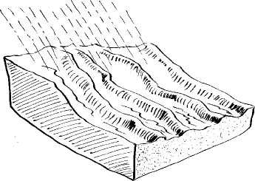B.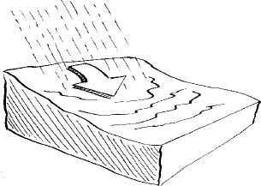 C.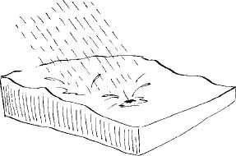 D.**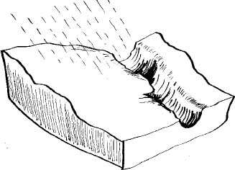

**Causes of erosion**

Natural causes of soil erosion take into consideration the following factors

1. **Climate**- sometimes wet and windy
2. **Topography**- the steeper the slope, the greater the rate of erosion
3. **Water flow**- Water moves faster on steeper slopes than flat lands
4. **Soil properties**- soils with poor texture, structure and water-holding capacity will be easy to move away.

**Cultivation practices**

1. **Cultivating on slopes**- up and down the hills rather that the use of contour lines
2. **Overcultivation**- use of the same land space repeatedly without resting.
3. **Overgrazing**- allowing livestock to feed on the land until soil is exposed
4. **Deforestation**- Cutting down trees for lumber, building houses, bridges or roads or even leaving the land bare after removing the trees.
5. **Slash and burn**- burning the dry weeds after applying weedicides.
6. **Tillaging**- ploughing the land and leaving it.

**Effects of erosion**

* Pollution of waterways
* Damage to land (land degradation)
* Soil loss from farmlands
* Loss of plant nutrients
* Breakdown of soil structure (surface crusting)
* Reduction in water-holding capacity

Solution to soil erosion- as was mentioned in the introduction above, the maintenance of soil or prevention of erosion will keep a fertile soil.

The following measure are ways of doing so:

* Afforestation
* Planting cover crops
* Intercropping
* Mulching
* Crop rotation
* Terracing
* Contour strip cropping
* Grass barriers

Activity:

1. Discuss briefly how each of the solutions above can prevent soil erosion while maintaining soil fertility.
2. Tell why erosion is greater on hillsides than on lowlands.
3. Name two crops that can be used to cover the soil as it grows.